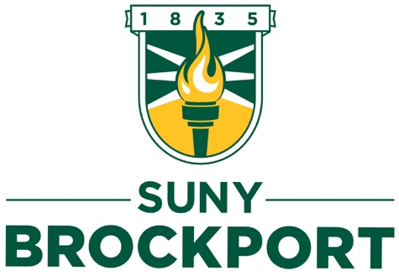
Institutional Review Board
Institutional Review Board (IRB) Authorization Agreement

Name of Institution or Organization Providing IRB Review (Institution A):
______________________________________________________
IRB Registration #: ___________ Federalwide Assurance (FWA) #: ___________
Name of Institution Relying on the Designated IRB (Institution B): SUNY Brockport
FWA #: 0001867
The Official signing below agree that SUNY Brockport may rely on the designated IRB for review and continuing oversight of its human subjects research described below (check one):
☐This agreement applies to all human subject research covered by SUNY Brockport’s FWA.
☐This agreement is limited to the following specific protocol(s):

Name of Research Project:
Name of Principal Investigator:
Study Number:
Please identify the extent of your involvement in this project as an agent of Institution B:
Sponsor or Funding Agency:
Award # (if any):

☐Other (describe):

The review and continuing oversight provided by the designated IRB will meet the human subjects protection requirements of Institution B’s OHRP-approved FWA. The IRB at Institution B will follow written procedures for reporting its findings and actions to appropriate officials at Institution A. Relevant minutes of IRB meetings will be available to Institution A upon request. Institution B remains responsible for ensuring compliance with the IRB’s determinations and with the terms of its OHRP-approved FWA. This document must be kept on file by both parties and provided to OHRP upon request.

Printed Name: ____________________ Title: ______________________________

Signature of Signatory Official (Institution A): _________________________Date: ________

Contact Information:

Printed Name: ___________________________ Title: ______________________________

Signature of Signatory Official (Institution B): ________________________ Date: ________

Contact Information:

SUNY Brockport
350 New Campus Drive
Allen 520
Brockport, NY 14420
(585) 395-2444 (voice)
irb@brockport.edu

